**A few testimonials from our customers**   
  
Angeli was very helpful in all our dealings with SunSibility, both at a personal level and in terms of connecting us with Tim, who supplied and fitted Llumar AU85 film

to all our windows to block UVA.

This has been life-changing; we have been living with blinds down and curtains drawn since my diagnosis with discoid lupus.

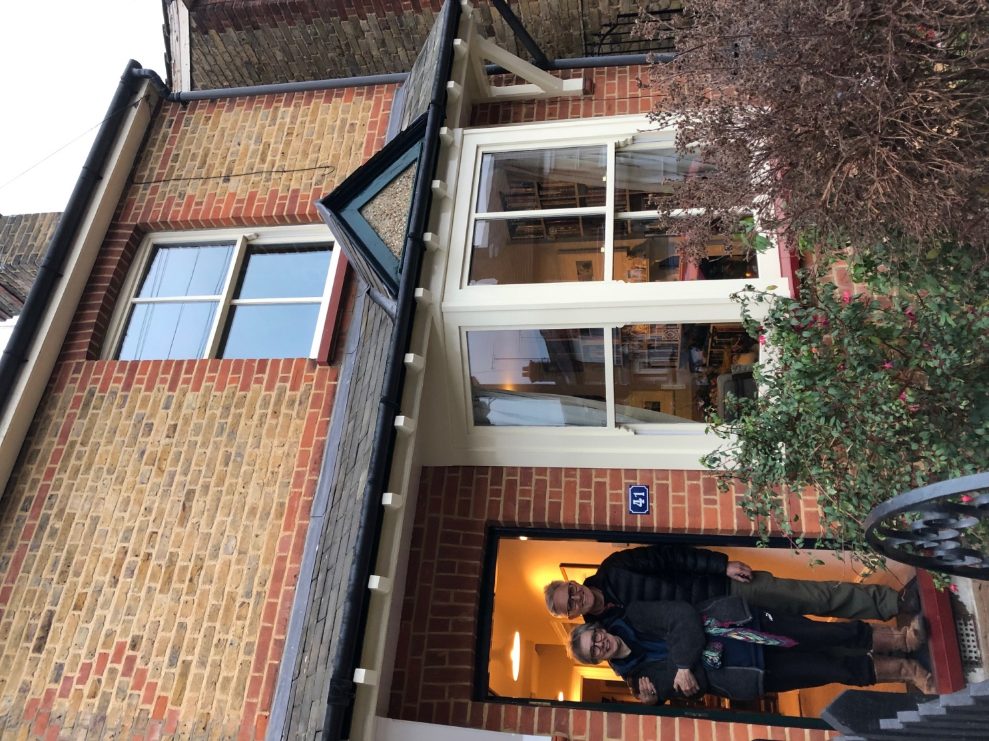

It is a huge relief to be safe from the sun indoors, and to be able to let in the

light without worrying and having to use sunscreen from dawn to dusk.

Angeli was positive, practical, kind and reassuring- as was Tim.  We are very grateful to have connected with them both

*R Matthews Essex*

Our fitter was exceptional.  He was professional, informative and very efficient.

It only took him and his helper two hours to do the house after cutting the pieces to

size where they work.

When they did the car, they picked it up in the morning and delivered it back at lunchtime.  Both these things have made my quality of life so much better, in fact really, really better !!

*Linda Dennis Cheshire*

The clothes we have purchased from SunSibility have enabled our daughter and us

to enjoy a summer outside. Our daughter has Actinic Dermatitis. This means that

her skin creates eczema within seconds of being exposed to UV Light.

We had previously tried sun suits from major retailers but she had still burnt through them. We had all but given up hope when we came across SunSibility. We tentatively purchased a long-sleeved turtle neck top not really believing it would work. How wrong we were!

The top fully protected her skin and allowed her to play outside as much as she wanted. In the summer, we holidayed in the Scilly Isles, where the UV is typically UV8 or higher.

We now own a number of SunSibility products and recently have had the pleasure of working with SunSibility to create some vests for her to wear under her school blouses. These will enable her to enjoy a normal school playtime and sports during the spring and summer months.

Also, the UV window film is a fantastic product, easy to use and very effective. See the [CBBC Dengineers Zen Den episode](https://www.bbc.co.uk/iplayer/episode/m000dn0j/the-dengineers-series-5-9-zen-den) if you want more info! We are fortunate and grateful to have found SunSibility and can’t recommend them and their products enough.

*Jennifer Giddings, Yorkshire*