SunSibility Glove Sizing Guide (cm)
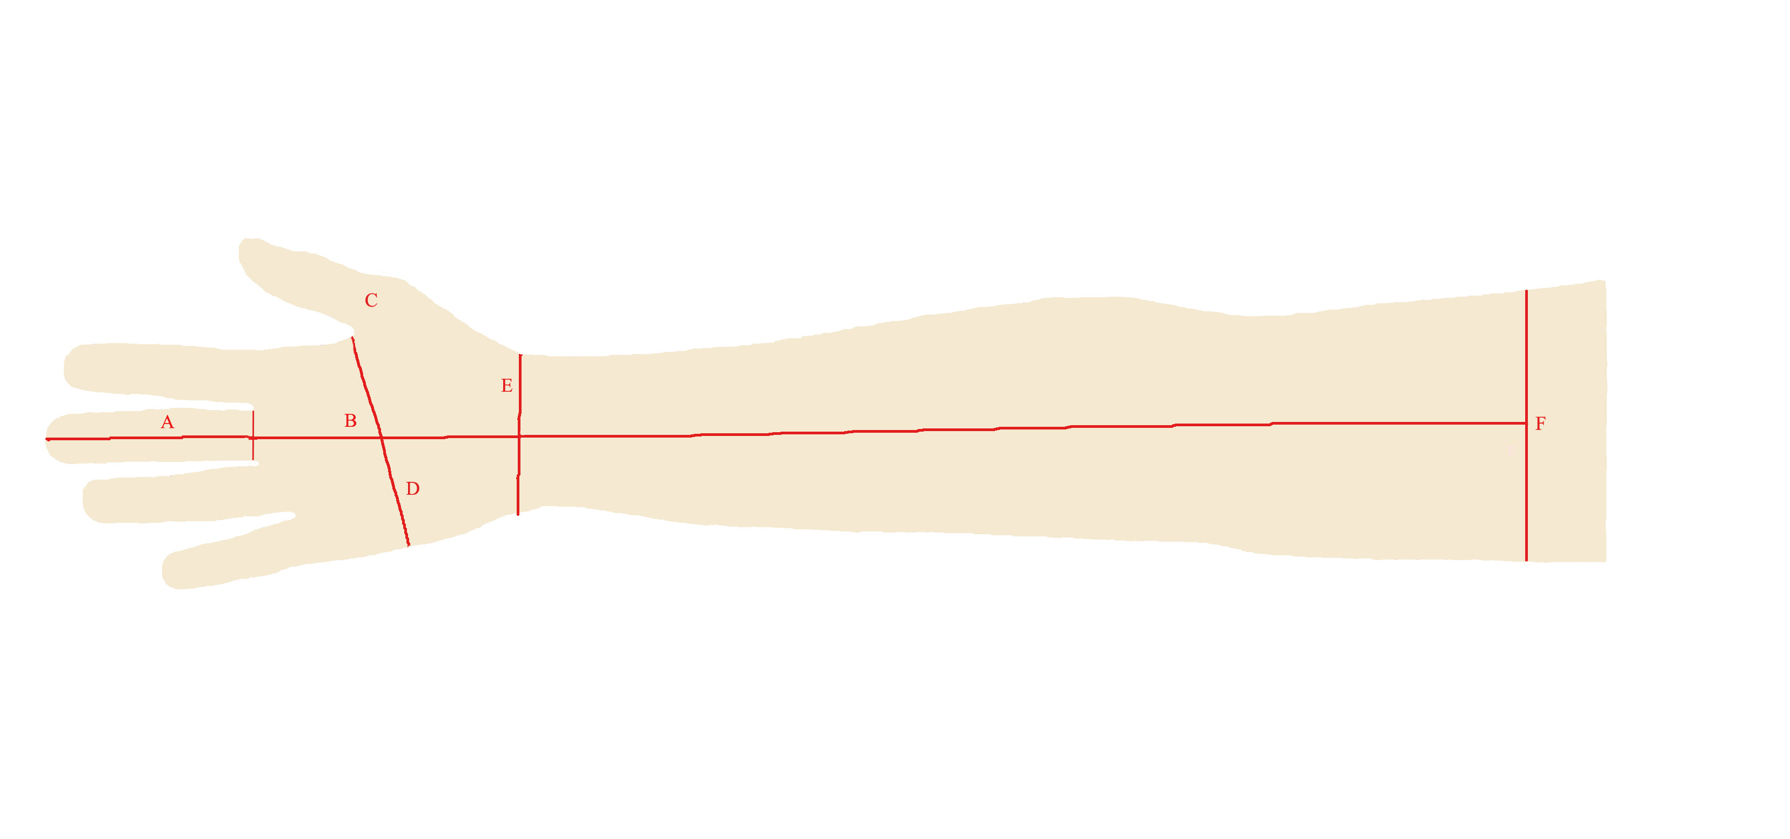

- MIDDLE FINGER LENGTH – Length from middle finger tip to base of finger at crease.
- PALM LENGTH – Length of palm from middle finger tip crease to first crease below palm.
- THUMB LENGTH – Length from thumb finger tip to base of thumb crease.
- PALM CIRCUMFERENCE – Circumference of palm starting at base of thumb webbing.
- WRIST CIRCUMFERENCE – Circumference of wrist measured at the base of palm.
- AVERAGE ARM CIRCUMFERENCE – Measured mid way between shoulder and elbow

Men’s Sizing Guide (cm)

 |  | S | M | L | XL
A | Middle finger length | 8.1 | 8.1-8.6 | 8.6-9.0 | 9.0-9.4
B | Palm length | 11.1 | 11.1-11.3 | 11.3-11.7 | 11.7-12.1
C | Thumb length | 6.4 | 6.4-6.8 | 6.8-7.1 | 7.1-7.4
D | Palm Circumference | 22 | 22-22.5 | 22.5-23.5 | 23.5-24.5
E | Wrist Circumference | 17 | 17.5 | 18 | 18.5
F | Average arm Circumference | 32 | 34 | 36 | 38
 | Available lengths
 | Short 5 cm / 2” | 5 | 5 | 5 | 5
 | Medium 25.5 cm / 10” | 25.5 | 25.5 | 25.5 | 25.5
 | Long 41 cm / 16” | 41 | 41 | 41 | 41

Women’s Sizing Guide (cm)

 |  | S | M | L | XL
A | Middle finger length | 6.9 | 6.9-7.4 | 7.4-7.8 | 7.8-8.2
B | Palm length | 9.7 | 9.7-10.0 | 10.0-10.4 | 10.4-10.8
C | Thumb length | 5.4 | 54-5.7 | 5.7-6.1 | 6.1-6.5
D | Palm Circumference | 18.5 | 18.5-19.5 | 19.5-20.5 | 20.5-21.5
E | Wrist Circumference | 16 | 16.5 | 17 | 17.5
F | Average arm Circumference | 27.5-29 | 29-30.5 | 30.5-32 | 32-33.5
 | Available lengths
 | Short 5 cm / 2” | 5 | 5 | 5 | 5
 | Medium 25.5 cm / 10” | 25.5 | 25.5 | 25.5 | 25.5
 | Long 41 cm / 16” | 41 | 41 | 41 | 41

Kid’s Sizing Guide (cm)

 |  | Toddler S | Toddler M | Toddler L | Kids S | Kids M | Kids L | Kids XL | Kids XXL
 | Age | 0-2 | 2-3 | 4-5 | 6-7 | 8-9 | 10-11 | 12-13 | 14-15
D | Palm Circumference | 11.5 | 13 | 14 | 15.5 | 16-16.5 | 18 | 19 | 20
E | Wrist Circumference | 11-12 | 11.5 | 12-13.9 | 14 | 14.3 | 16 | 16 | 17
J-K | Length from wrist to tip of the middle finger | 10.5-11 | 11.5-12 | 12-12.5 | 14 | 14.5 | 16.5 | 17-18 | 18-19
H | Bicep Circumference | 15-16 | 15.5-16 | 17 | 18 | 19 | 22.2 | 22.8 | 25-27
 | Mid finger length | 4 | 4.5-5 | 4.8-5 | 5.6 | 6.5 | 6.9 | 7.5 | 8
 | Palm | 4.5 | 5.5 | 6.8-7.1 | 7.6-8 | 8.2 | 9.1 | 10 | 10.6
 | Thumb | 3 | 3.5 | 4 | 4.5 | 5 | 5.5 | 5.9 | 6.3
 | Below elbow circumference | 15 | 16 | 17 | 18 | 20 | 22 | 24 | 26
 | From wrist to elbow | 12 | 14 | 15 | 17 | 19-21 | 23 | 25 | 27-28
 | Arm length | 31 | 40 | 46 | 49 | 54.5 | 59 | 64 | 68
 | Available lengths (measured from wrist)
 | Short | 3 | 3 | 3 | 5 | 5 | 5 | 5 | 5
 | Mid length | 8.2 | 9.2 | 14 | 14.5 | 18.5 | 17 | 20.5 | 22
 | Long | 15.3 | 18.3 | 25.5 | 26.5 | 21.5 | 30 | 35.5 | 37.5

